Customer Churn Analysis Report

This report presents the exploratory data analysis (EDA) and data preparation steps undertaken to support the development of a predictive model for customer churn. It outlines the data identification process, key exploratory findings, and the cleaning and preprocessing steps applied to prepare the dataset for model development.

Data Identification and Collection
The following data sets were identified as relevant for predicting customer churn:
- Transaction History
- Customer Service Interactions
- Online Activity
- Churn Status
These data sets were selected as they collectively capture customer engagement, satisfaction, and behavioural patterns. Transaction data reflects financial activity, customer service interactions highlight potential dissatisfaction, online activity indicates digital engagement, and churn status provides the target variable for prediction.

Exploratory Data Analysis
Exploratory data analysis was conducted to uncover patterns and relationships that could inform predictive modelling. Visualisation and descriptive statistics were used to examine distributions, trends, and anomalies across the data.
Key findings from the analysis include:
- Customers who churned generally showed lower transaction activity and spending levels.
- Unresolved customer service interactions and complaints were more prevalent among churned customers.
- Lower login frequency and longer periods of inactivity were associated with a higher likelihood of churn.
The following figures were used to support these insights:
Figure 1: Distribution of customer transaction activity
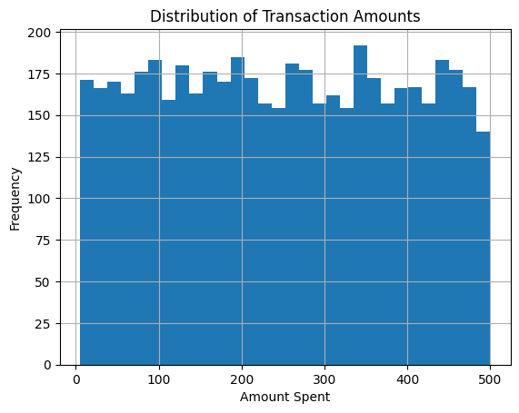

Figure 2: Customer service interaction outcomes and churn
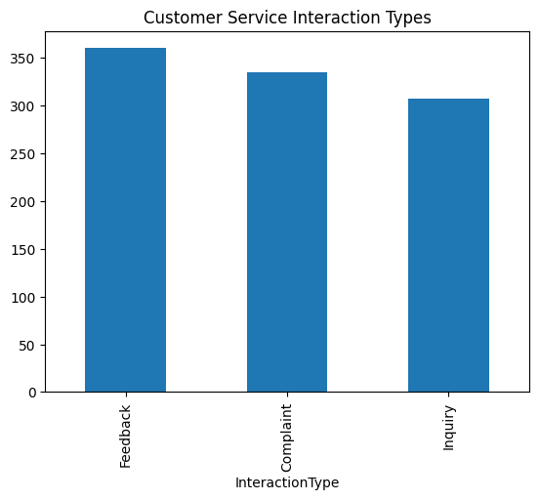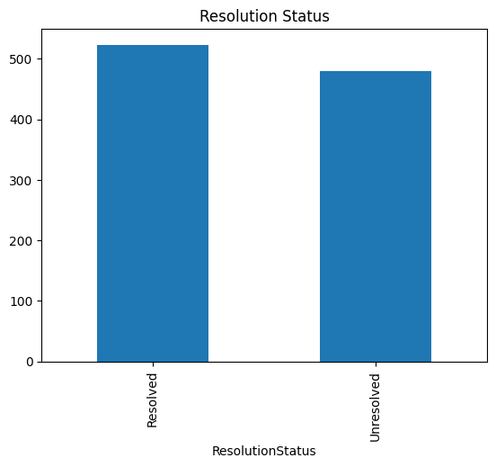

Figure 3: Login frequency comparison between churned and retained customers
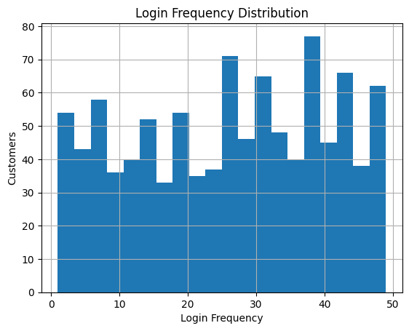

Figure 4: Overall churn distribution across customers
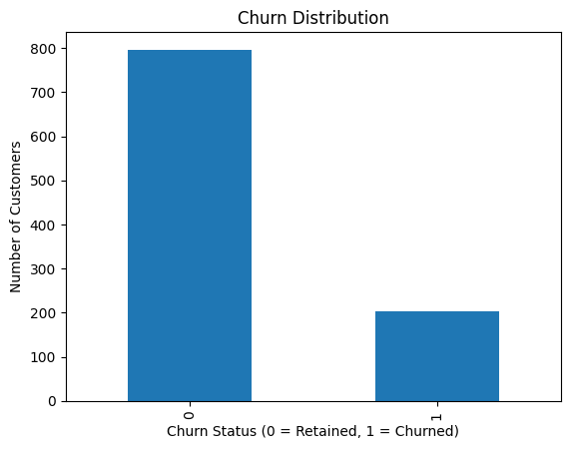

Data Cleaning and Preparation
Data cleaning and preprocessing steps were applied to ensure the dataset was suitable for machine learning.
- Missing values were handled using median imputation for numerical variables and mode imputation for categorical variables.
- Outliers in numerical features such as transaction amounts and login frequency were capped to reduce skew while retaining valid customer observations.
- Behavioural features were aggregated at the customer level to better represent engagement and activity.
- Numerical features were standardised to ensure consistent scales across variables.
- Categorical variables were encoded using one-hot encoding to convert them into a numerical format appropriate for modelling.
The resulting dataset is clean, structured, and ready for use in subsequent churn prediction modelling tasks.

